Developmental Profiles of Middle School Students

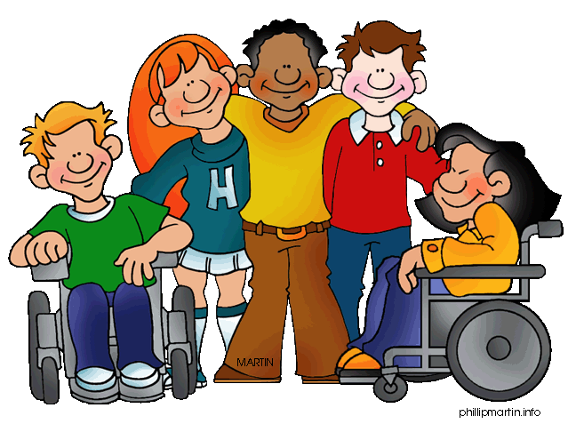

The Electric Eleven-Year-Old

Powerful advocates and strong believers, elevens are passionate about their ideas and opinions, allegiances and sense of justice. They’re devoted to classmates and peer groups, and the social negotiations surrounding cliques (which often peak at eleven and twelve) can be positive practice for teenage and young adult affiliation and attachment. Elevens’ social practice includes all the usual heartache and cruelty associated with forming and losing friendships—adults must respond to bullying with clear guidance and redirection.
Clearly in a physical and cognitive growth spurt, elevens often appear awkward. They’re actively engaging whole new worlds with outward boldness, yet inward tentativeness. Everything at eleven is in rehearsal.
Praise elevens for that rehearsal, remembering that their pronouncements are less sure than they sound, their assertiveness probably not intended as rudeness. Notice their voluminous rough drafts, their sketches and doodles—these things matter to elevens. Find ways to respond to them in writing. Such communication “at a distance” lets adults continue building strong relationships with eleven-year-olds.
Even elevens’ “contemptuous” behavior is a positive. With their eye-rolling, teeth-sucking, deep-sighing, tongue-clicking, shrugging, “whatever” posture, they’re practicing “distancing”—establishing physical and social safety when sensing a threat from another. And who better to first practice with than trusted teachers!
Elevens prefer learning new skills to honing old, but they’re proud of revision and final-draft excellence, despite their complaints. Teaching formal debate channels elevens’ need to be contrary and their sense of justice. Arguing an opposite opinion gives them great lessons in perspective-taking and empathy.
Elevens do well with project and service learning, especially when it’s their idea. Homework can be a hassle, but the more they’re held responsible, the more they learn from the positive logical consequences for accomplishment—and the negative consequences for not following through.
Elevens are ready to spread their wings a little. Parents often report better behavior away from home and moodiness around the family—where it’s safest to show their insecurities. Less grown up than they sometimes wish, elevens can still completely enjoy retreating to younger childhood patterns. They’re truly tweens.

In this series based on Yardsticks: Children in the Classroom Ages 4–14, Chip Wood focuses on the positive developmental attributes generally present in children at different ages.

The Twixt Twelve-Year-Old

Closer to teenagers than to middle childhood, twelves are tweens. They have enormous positive energy for independent and group endeavors, whether at school, in sports, or in after-school activities.
Twelves generally demonstrate confidence and friendliness in their approach and responses to adults outside the home. They’re eager to grow in their skill competencies, academic or otherwise. They get deeply invested in project-based or service learning and can develop meaningful relationships with people outside their core peer group. “Gregarious” is a word well-suited to twelves.
In school, twelve-year-olds make wonderful one-to-one tutors for younger children—or helpers in preschool or kindergarten.
Democracy and responsibility are important to twelve-year-olds. They thrive with their first forays into student government, serving on a social committee, running a school store, helping in the school office, managing daily announcements, producing a TV show for closed-circuit broadcast, taking charge of all-school meetings, serving as peer mediators, being in plays and musical productions, or playing in the band. Many children demonstrate amazing leadership potential at this age.

The Thriving Thirteens

The thirteen-year-old has lots of positive attributes to help navigate the first of these teen years. At the forefront are a keen sense of humor and a sense of silliness that makes for good fun in school hallways, on the bus.
Both boys and girls are undergoing significant physical changes by the time they are thirteen. Young teens often do feel awkward in their changing bodies, but they are also aware that these changes mean they’re no longer little children.
Thirteen-year-olds, of course, seek significance and belonging primarily from their peers and spend a great deal of positive energy trying to fit in. They enjoy constructive activities like band, dance, and sports. They also find that time by themselves is important, and they can be quite introspective as they enter their teen years.
Thirteens’ most positive attribute is their high energy, expressed in physical and verbal extravagance. Arguing is a sport and leisure pastime. They love to contradict. Teachers in seventh and eighth grade know the value of formal debate in any subject area and of problem-solving with more than one right answer. Also valuable is perspective drawing in math and art. Looking at the world from new points of view is the job of the thirteen-year-old and they do this job with delight and bravado.
Thirteen-year-olds want more freedom and will thrive with reasonably increased level of responsibility. Choices of tasks requiring new skills such as such as community service learning, student government, or tutoring younger children can meet with more success than having the only major school responsibility being to get their homework done.
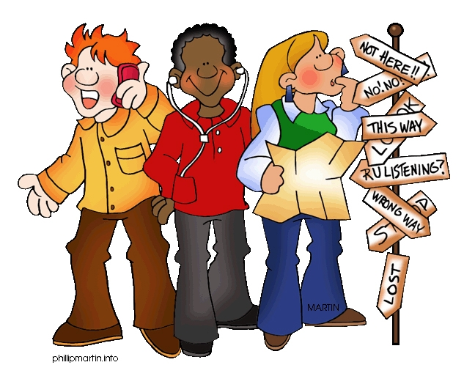

The Fervent Fourteens

Fourteen-year-olds seem to have mostly gotten used to the idea of being teenagers. Their moods are not as mercurial as at thirteen. They are somewhat more comfortable in their own skin and changing bodies. They seem to communicate more easily with each other.
Fourteens’ significant positive attribute is a growing ability to self-evaluate, to be more aware of their own gifts and challenges. They now think and reason more abstractly, showing more adult-like understanding of right and wrong. They express this often by taking sides, being righteous about issues of social justice and fairness at school and in society. Many thrive in classrooms where debate and discussion among students is encouraged, where cooperative projects are graded by student-created rubrics, where mock trials and academic games abound.
At fourteen, the hardest thing to do is to sit and listen to any adult for extended periods of time. Fourteens are convinced that they know what to do or what is expected as soon as an adult begins to speak. They are not, therefore, always good at following directions, but they are great at inventing new ones.
Fourteen-year-olds love their peer cultures. Bonding with a small social group or clique, often to the exclusion of others, is how they get their first apprenticeship experience with the adult values of loyalty and fidelity. Loyalty to the band, a sports team, a service club, or even to a beloved family member usually can provide the kind of positive modeling that helps to build the capacity for fidelity and commitment in later life. The opportunity to practice this positive attribute is key at this age.

Common Behavior Challenges with Middle School Students

Students may:
- Have friendship conflicts that are intense and bitter, ready to proclaim, “My friend isn’t fair to me,” while just beginning to ask, “Am I fair to my friend?”
- Identify class scapegoats and exclude children socially.
- Stick with the same friends unless the teacher assigns new partners.
- Can harshly reject those with different interests, often defending prejudices (picking on people who are short, overweight, quiet, etc.).
- Relate self-esteem to their achievement in school or athletics, or their ability to attract attention.
- Fear inferiority, which may lead to reluctance to expose their weaknesses or to take risks.
- Be afraid to explore and solve problems.
- Be afraid to offer ideas and opinions.
- Need to feel more in charge of themselves, but still rely strongly on teacher authority to set realistic goals and workable limits.
- Test limits and routines.
- Challenge and criticize their teacher or school codes.
- Worry that things are ‘babyish’ and demand privileges or responsibilities they are not ready to handle.
- Inconsistent and illogical, handling small responsibilities poorly yet lobbying for big ones.
- Struggle for a sense of identity—‘Who am I?’ is the big question.
- Begin the search for fidelity—a true, meaningful relationship with someone becomes the all-consuming quest.
- Spend hours on the phone, on-line, and in front of the mirror—defining themselves by the social culture and older students.
- Want adults to both notice them and leave them alone, wanting to be acknowledged as individuals yet often extremely embarrassed by adult recognition.
- Show lots of contempt for adult authority and often look bored, aloof, and disengaged—an outward appearance driven by their perception that adults don’t see them as capable people.
- Often are withdrawn and touchy, sensitive about everything from their schoolwork to their physical appearances.
- Swing from days of depression to days of giddiness, shrieks, and shouts.
- Can be more sarcastic.
- Are more disorganized—keeping track of assignments, books, and papers is a low priority.

